**Launch Linux EC2 instances in two regions using a single Terraform file.**

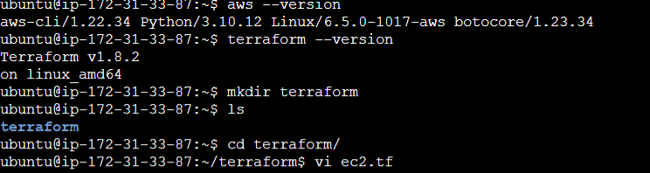

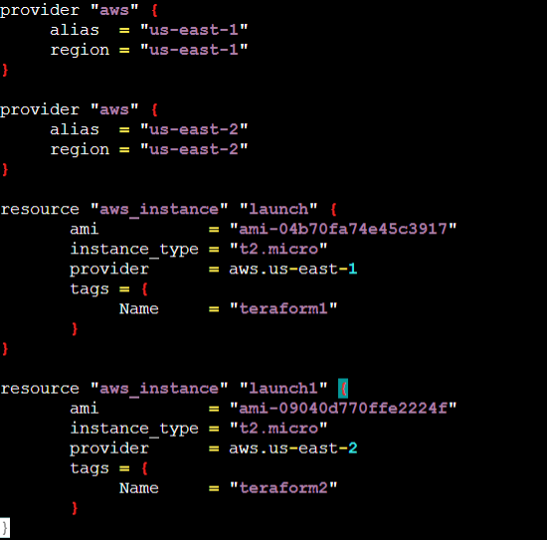

**USE COMMANDS: terraform init**

**terraform plan**

**terraform apply**

